Link - <https://verify.staging.omnicrm.co/b/client_form/forms/qc_form_list>

Index no. ---- 20

I tested all case id. 1 is Add to Query (case id is 140619)

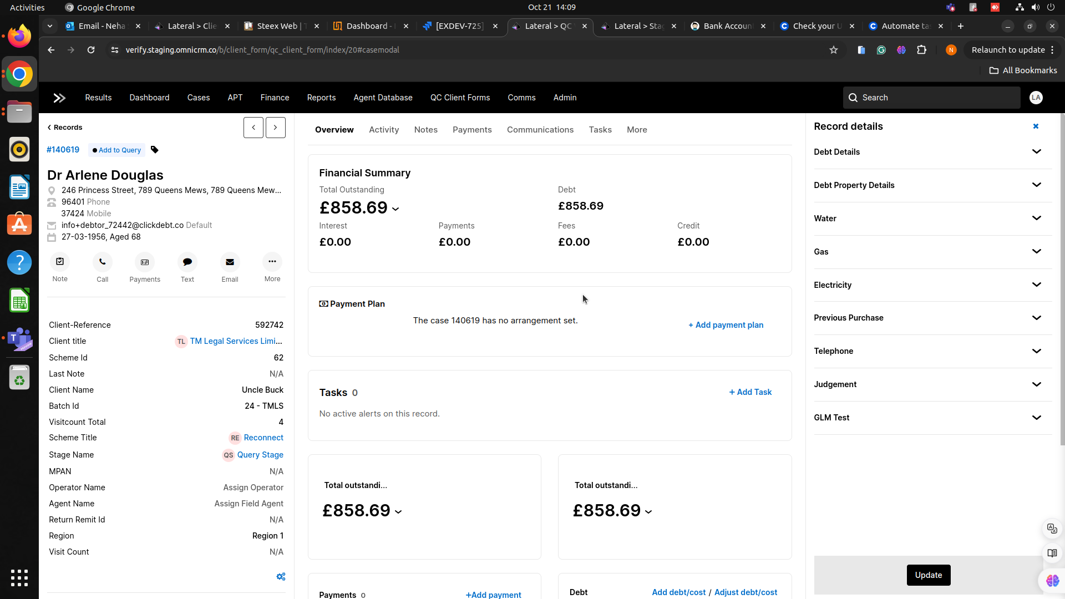

Index no. ---- 15

I tested all case id. 9 is Add to Query.

Case id-140533, 13200172,144145,131153,157258,154981,143803,143160

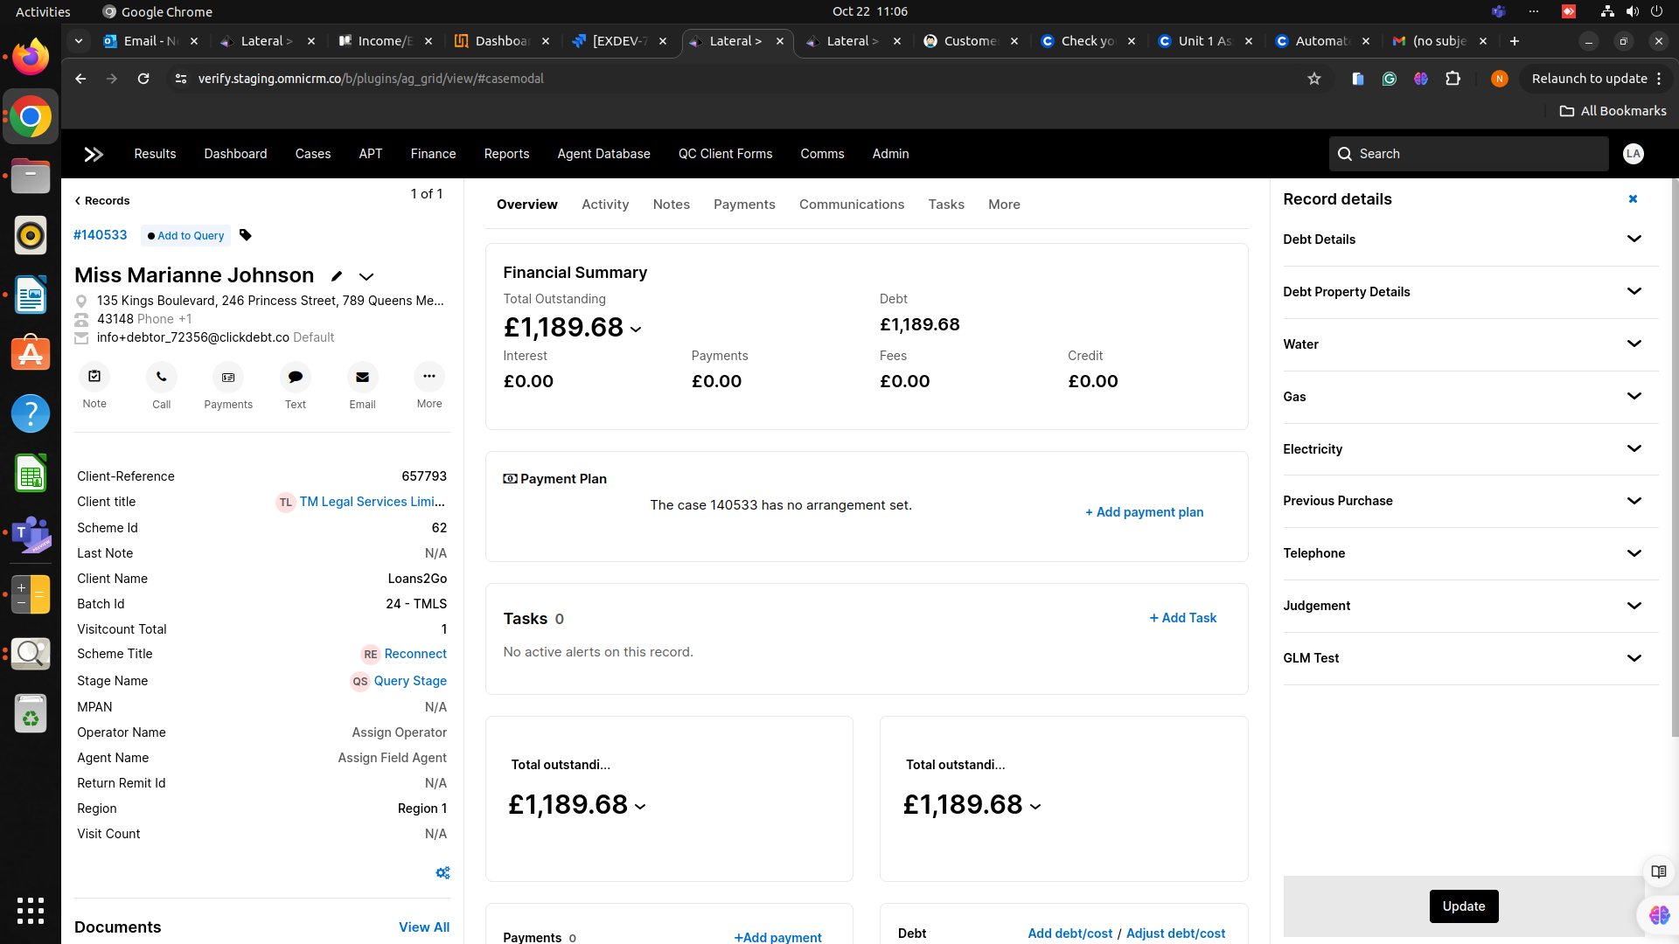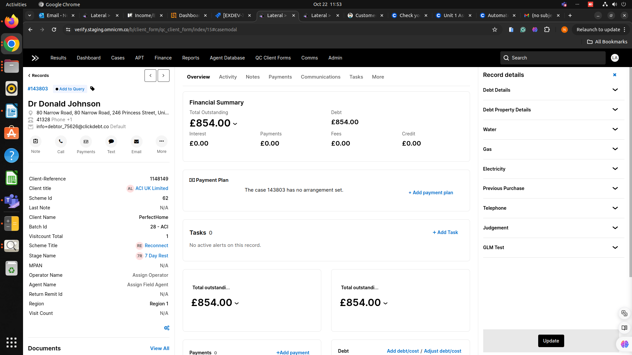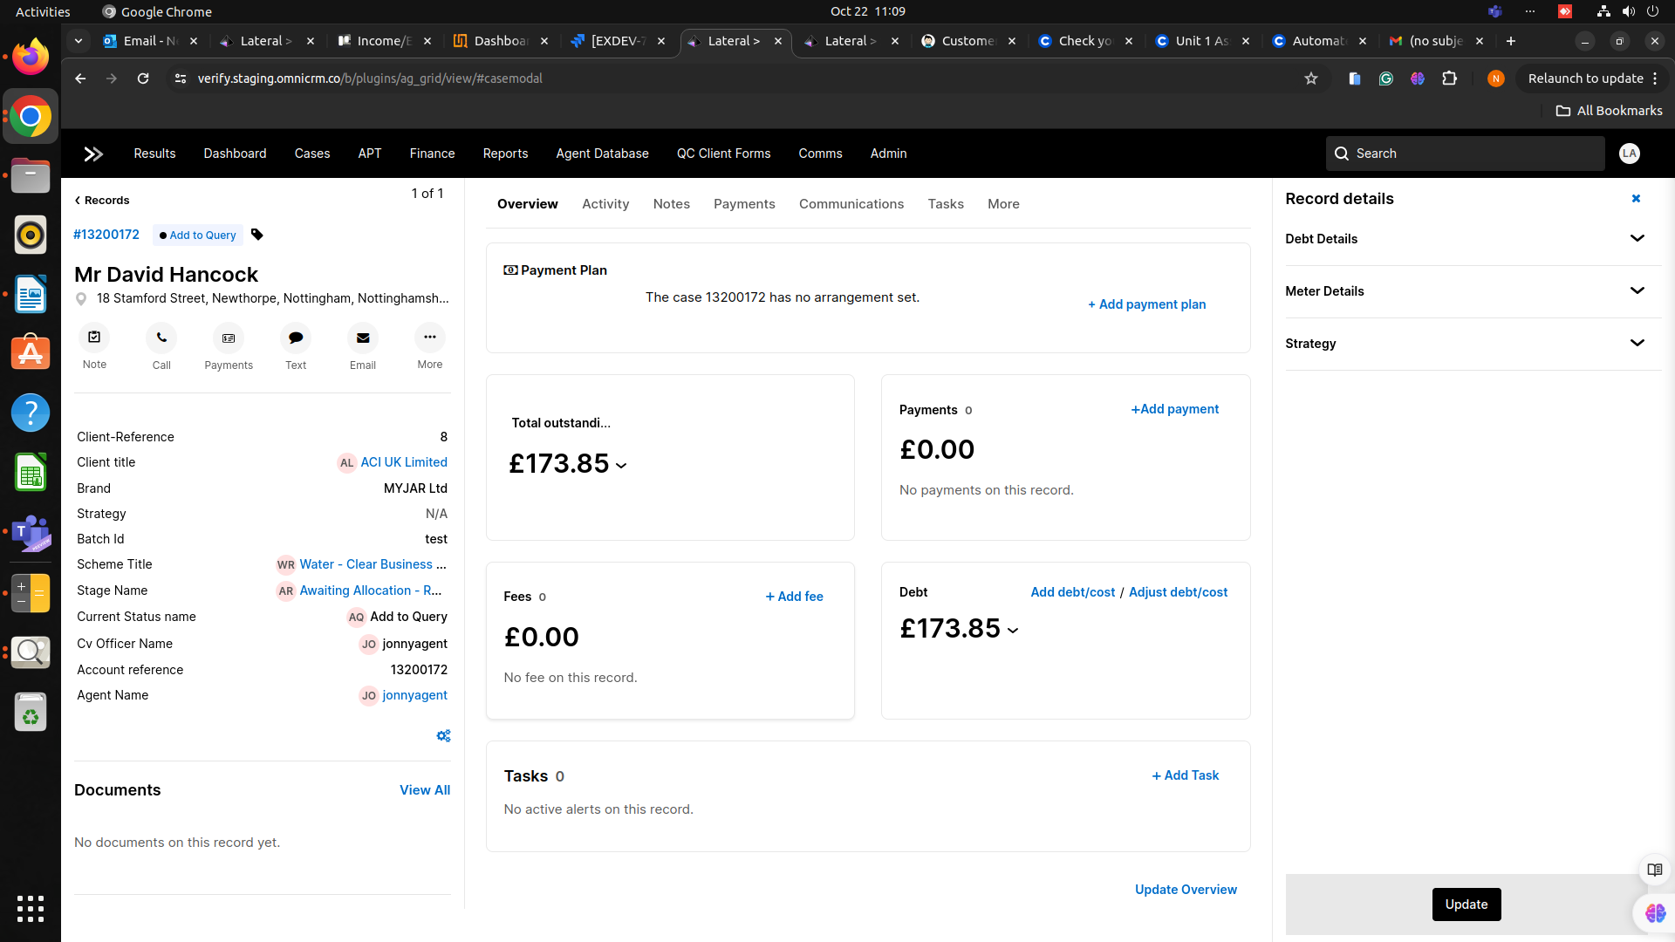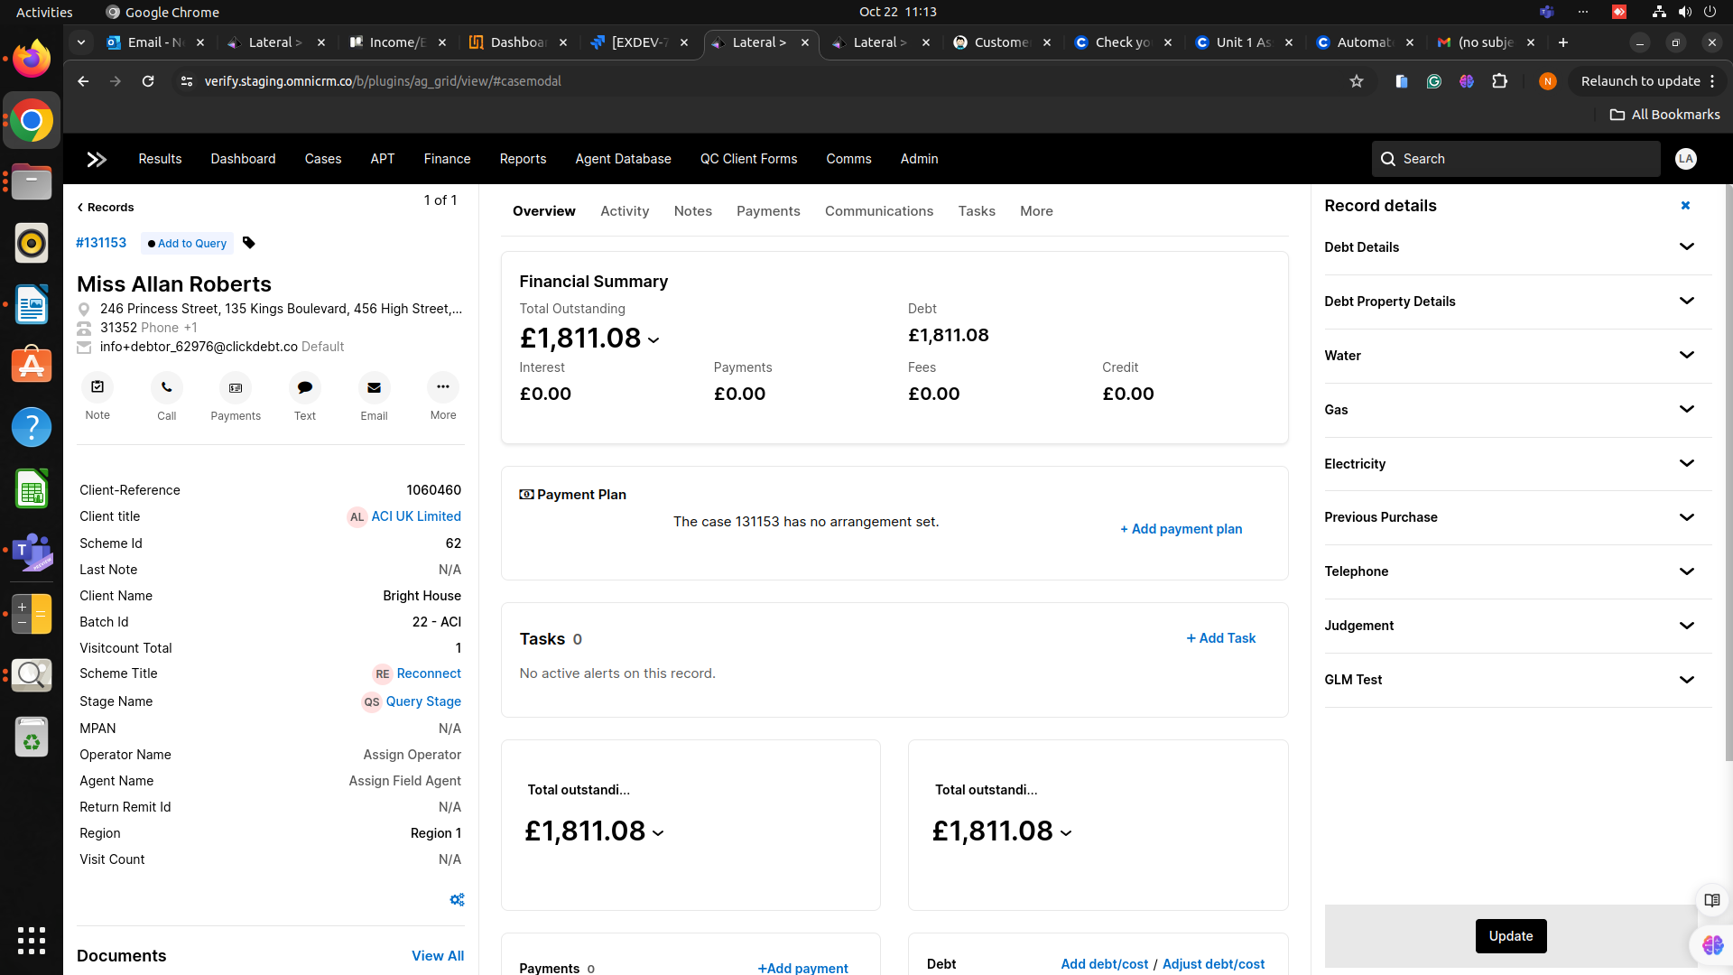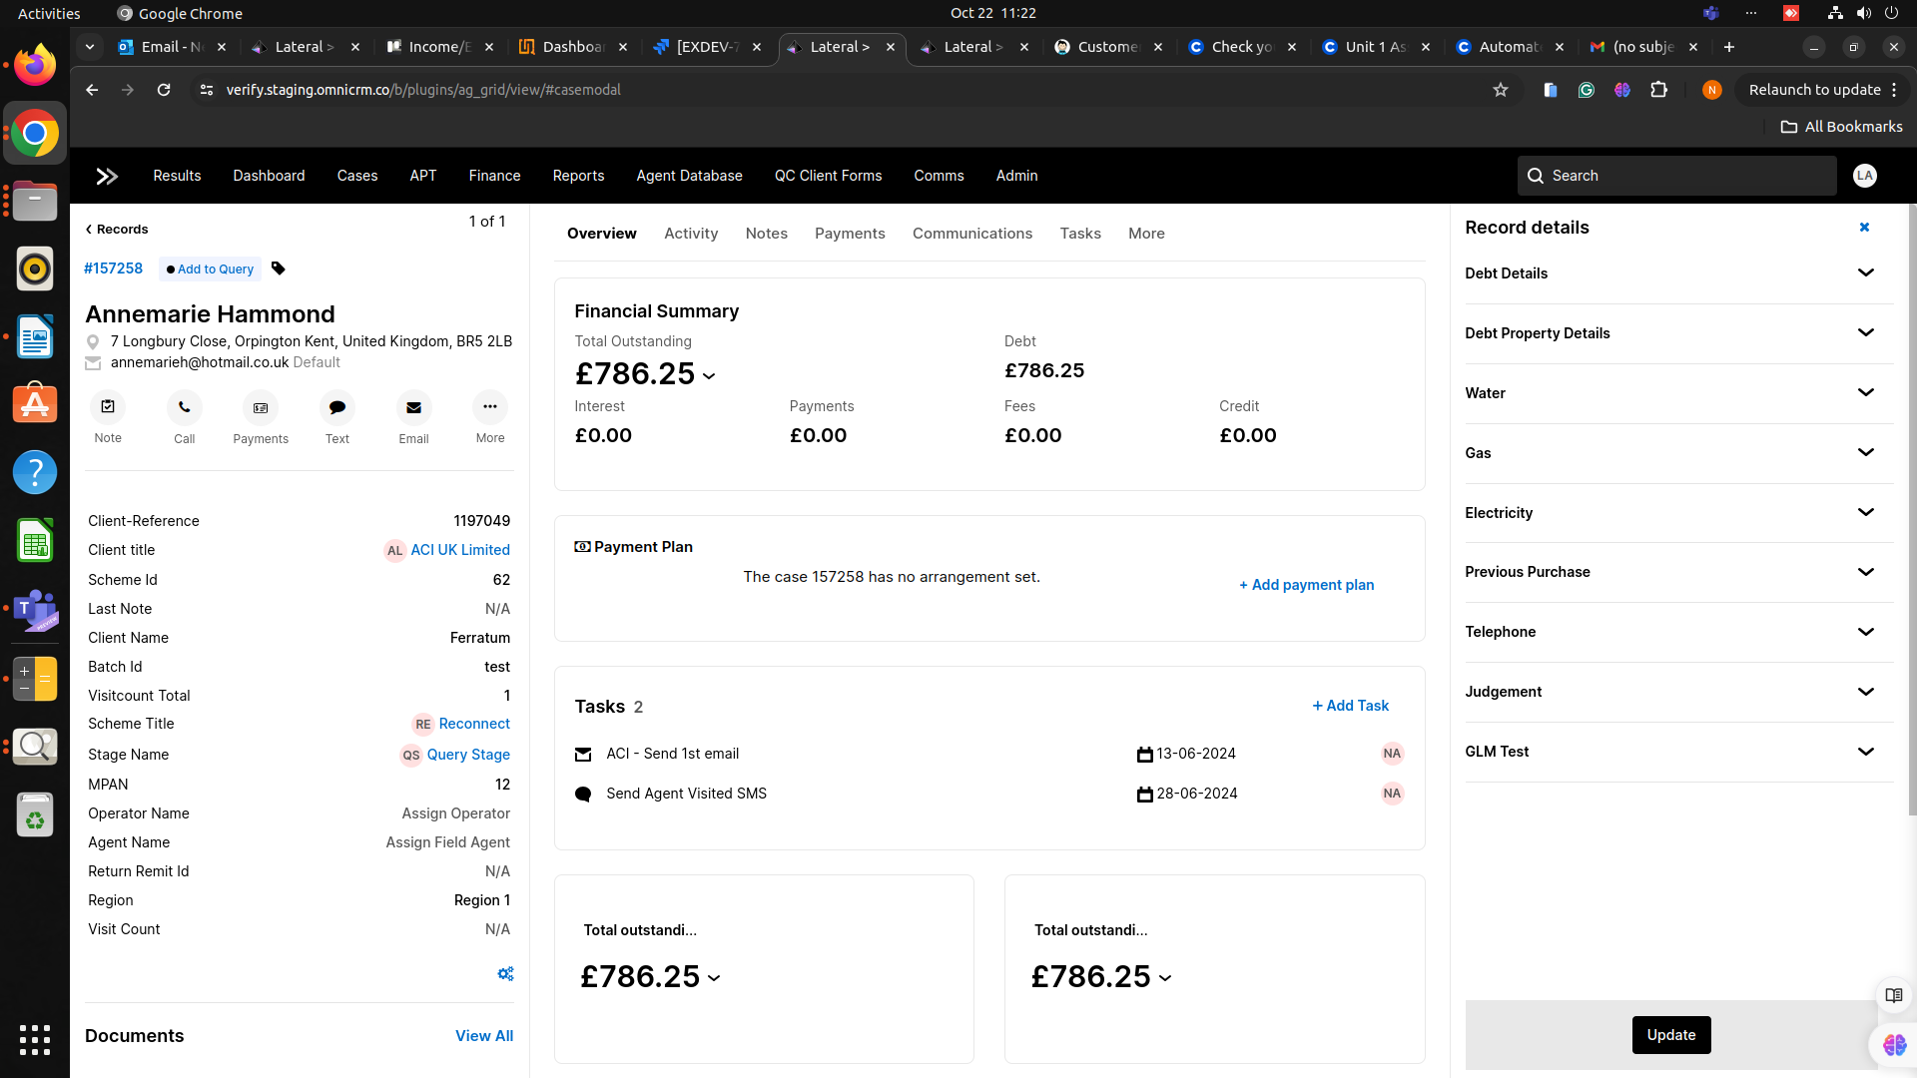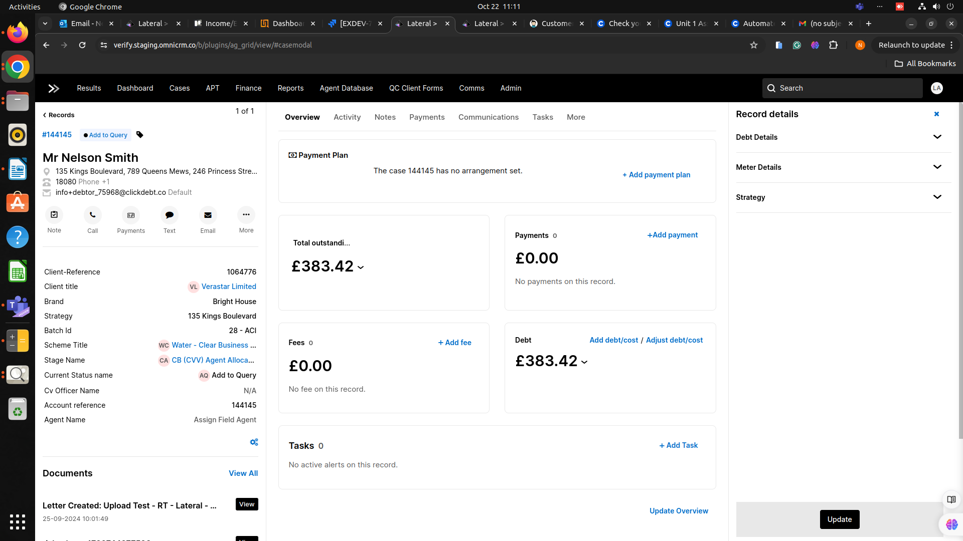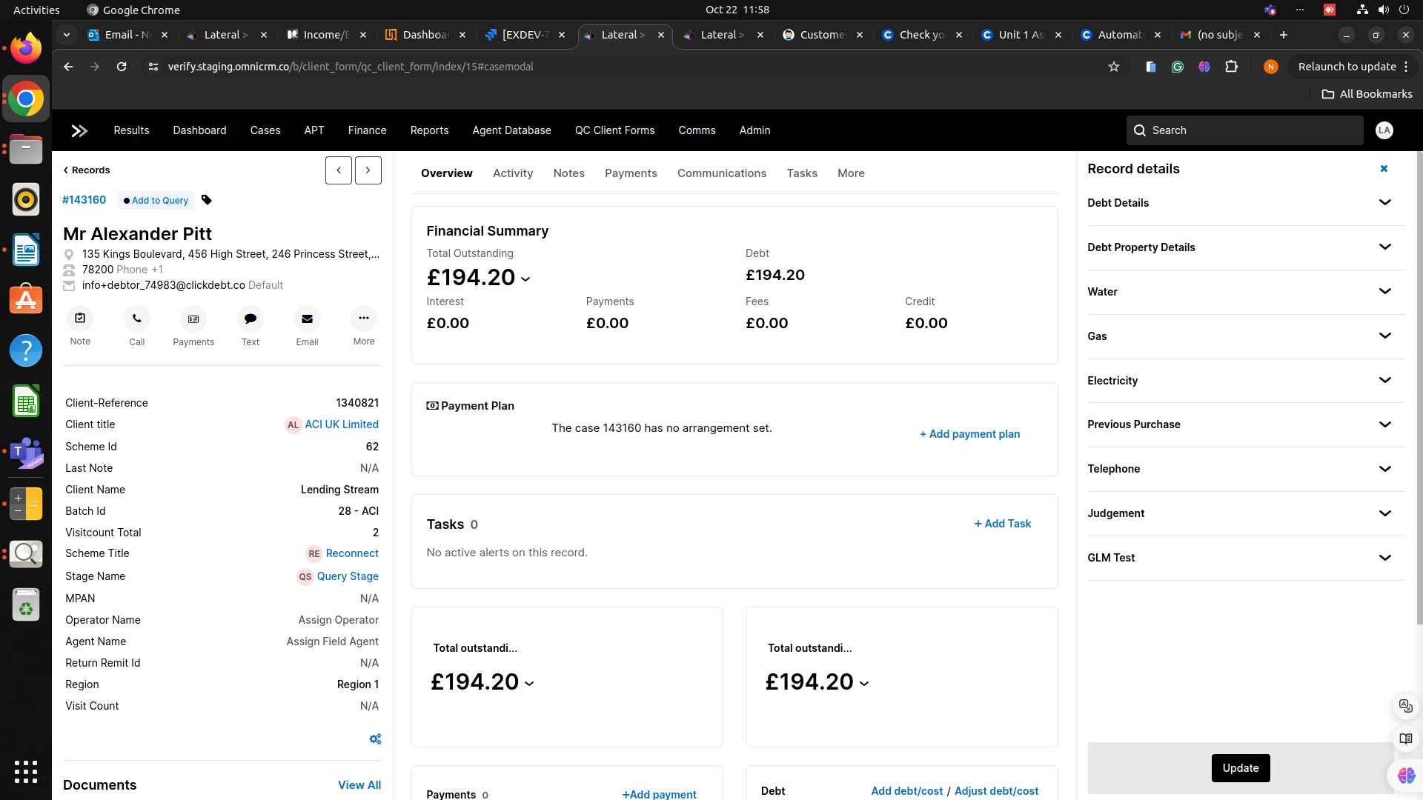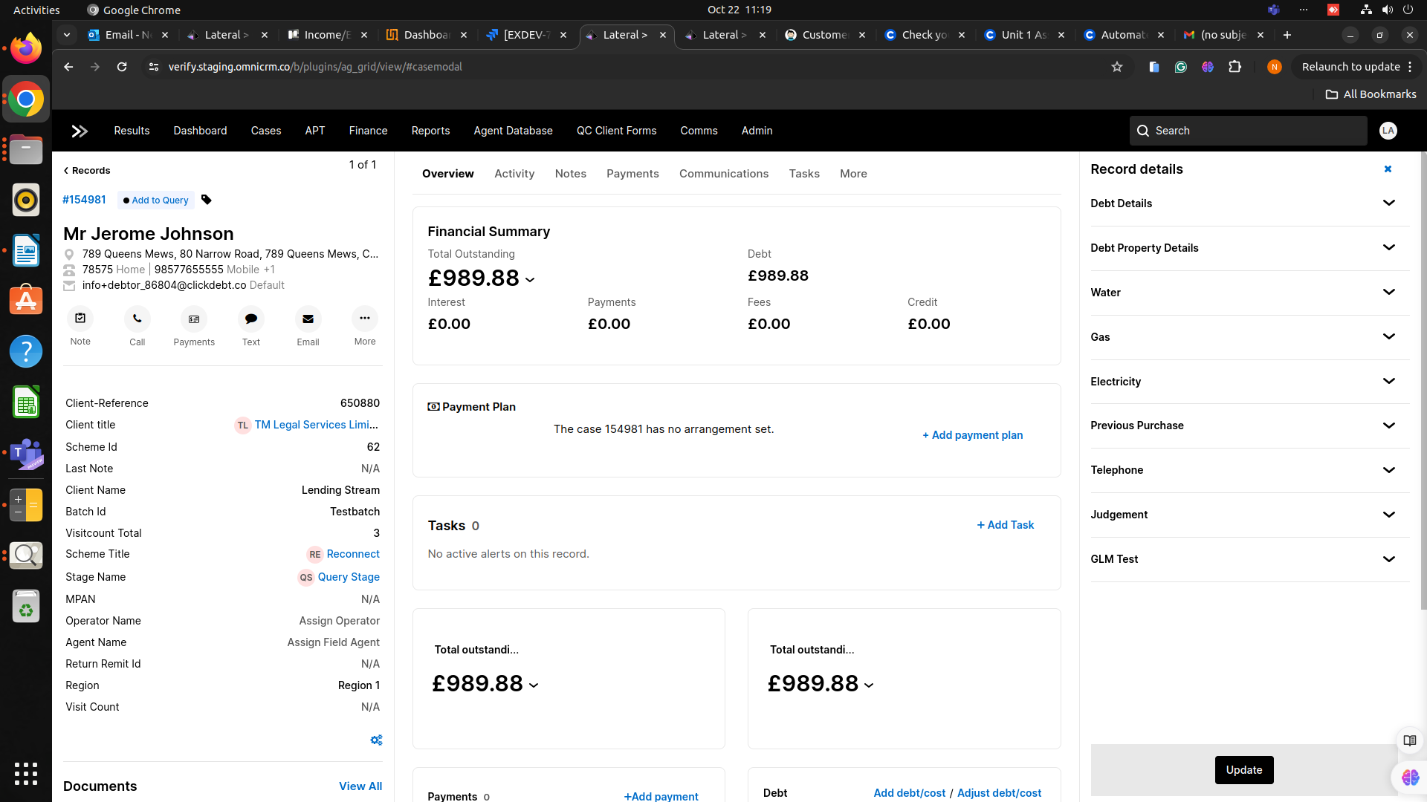

And other case id-

155019,84131,83422,83471,83475,139234,157254,157312.